Supporting Information for

**3D velocity and anisotropy structure of the southeastern Tibetan Plateau extracted by the joint inversion of wave gradiometry, noise tomography and receiver function**

Feihuang Cao12, Chuntao Liang12, Yihai Yang3, Lu Zhou12, Zhiqiang Liu12, Zhen Liu12

1Key Laboratory of Earth Exploration and Information Techniques of the China Ministry of Education, Chengdu, China 1.

2 State Key Laboratory of Geohazard Prevention and Geoenviroment Protection, Chengdu University of Technology, Chengdu, China 2.

3Shaanxi Earthquake Agency, Xi’an, Shanxi, P.R. China 3.

Corresponding author: Chuntao Liang ([liangct@cdut.edu.cn)](mailto:liangct@cdut.edu.cn))

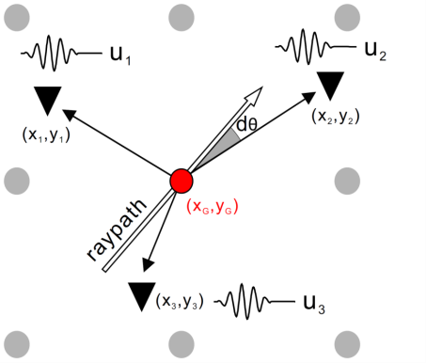

**Figure S1**. Diagrams of subarray with reference location of grid point. Black triangles represent supporting stations; dots mark the grid point, where the red dot denotes the reference location.

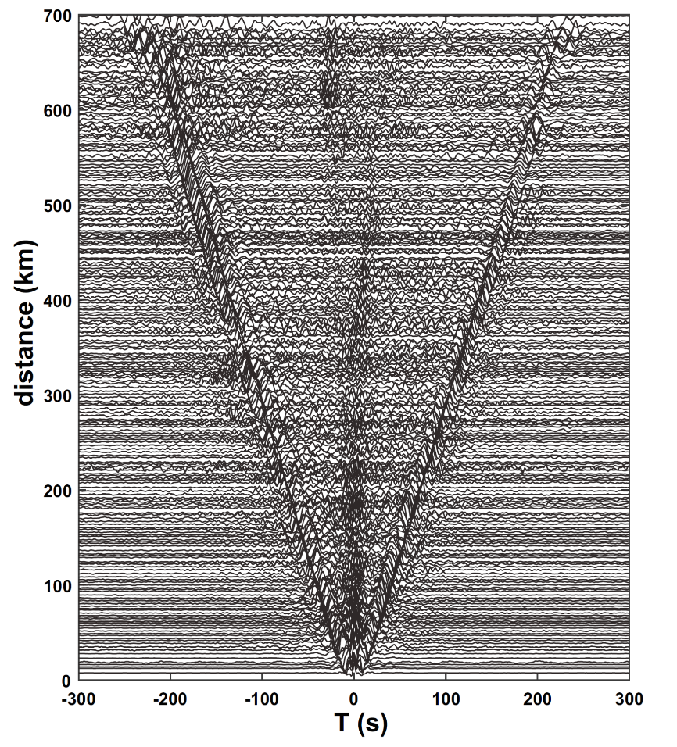

**Figure S2.** Cross-correlations of ambient seismic noise recorded by the the Temporary Western Sichuan Array

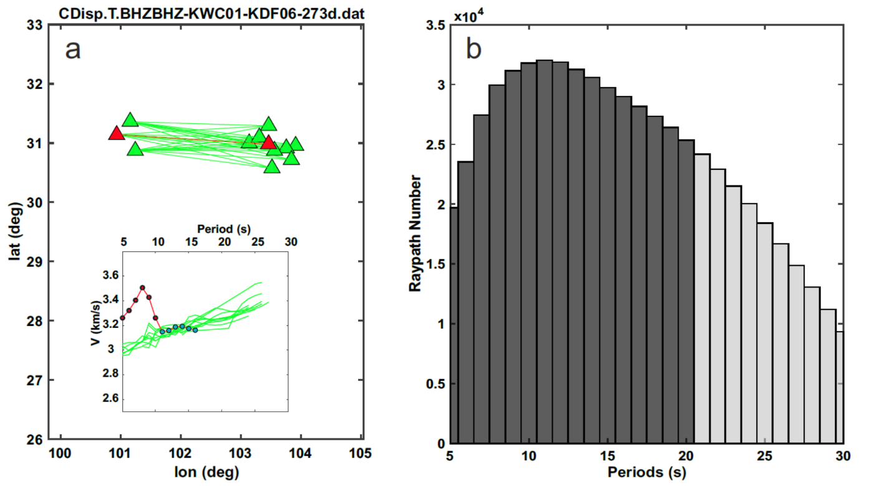 **Figure S3.** (a) Dispersions curve of similar raypath (straight lines) obtained by ambient noise tomography, the green curves are the dispersion of green raypath, red curve is the target dispersion of red raypath, red dots on the red dispersion are the discarded dispersion points. (b)The raypath number in different periods.

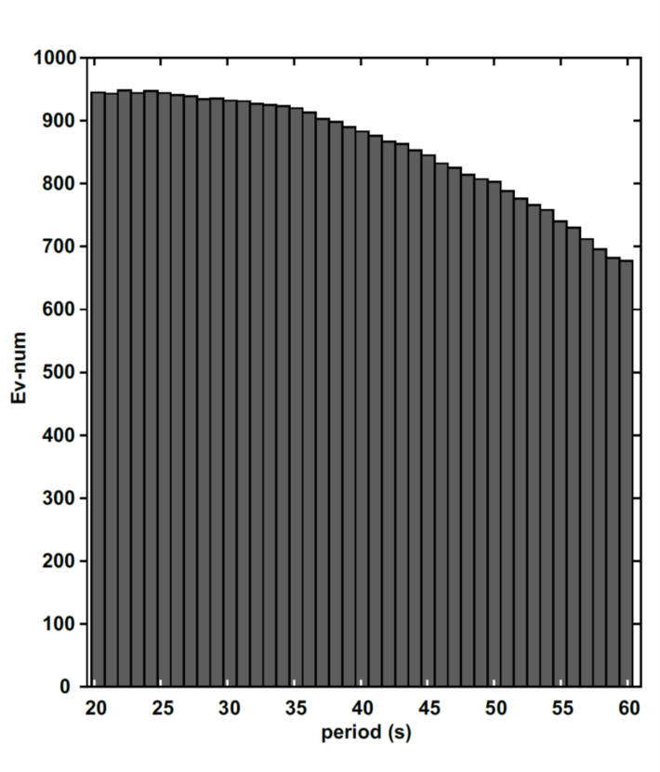

**Figure S4.** The earthquakes used in wave gradiometry analysis in different periods.



Figure S5. Rayleigh wave velocities and azimuthal anisotropies determined from numerical experiment. (a) the recovered model of Mod7 which Synthetic wave with Gaussian factor of 0.012 and random noise N = 5% (brown waveform) and filtering waveform with center period of 60 s (black waveform). (b) Information given in (a), but for Mod8 which with random noise N = 10%.

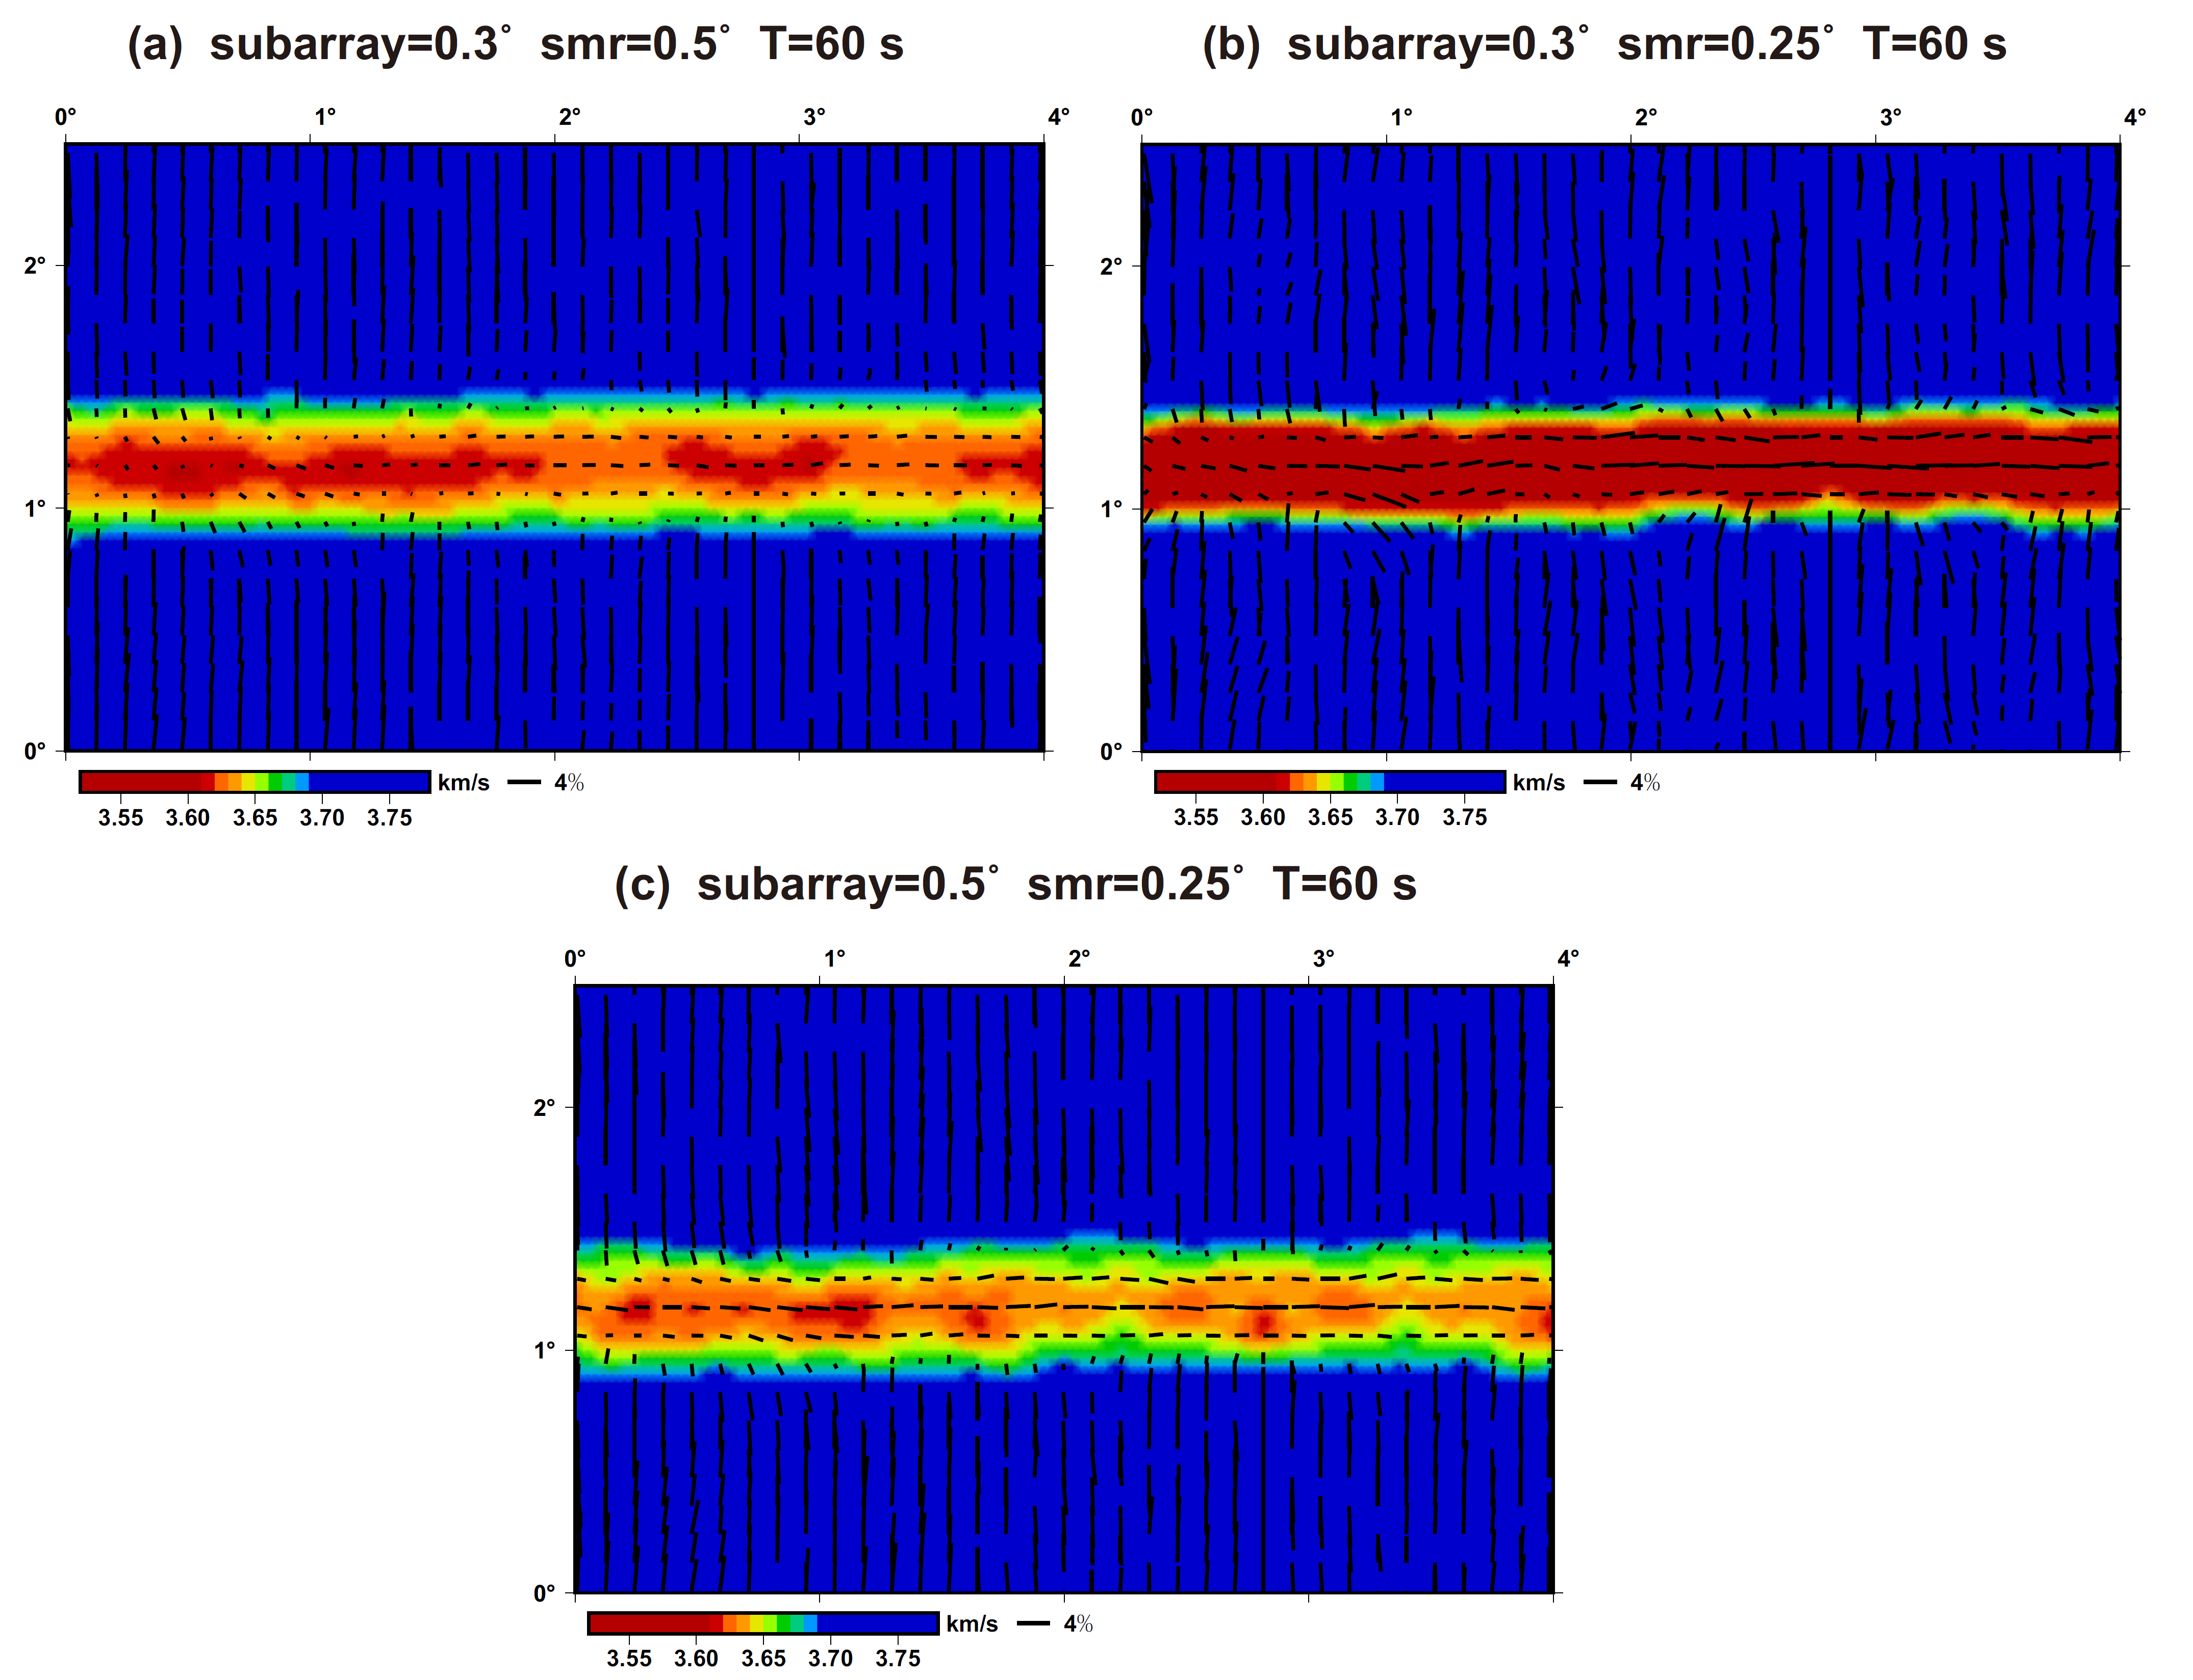

Figure S6. Rayleigh wave velocities and azimuthal anisotropies determined from WG numerical experiment. Figure (a), (b) and (c) are the recovered models of Mod9, Mod10 and Mod11, respectively.

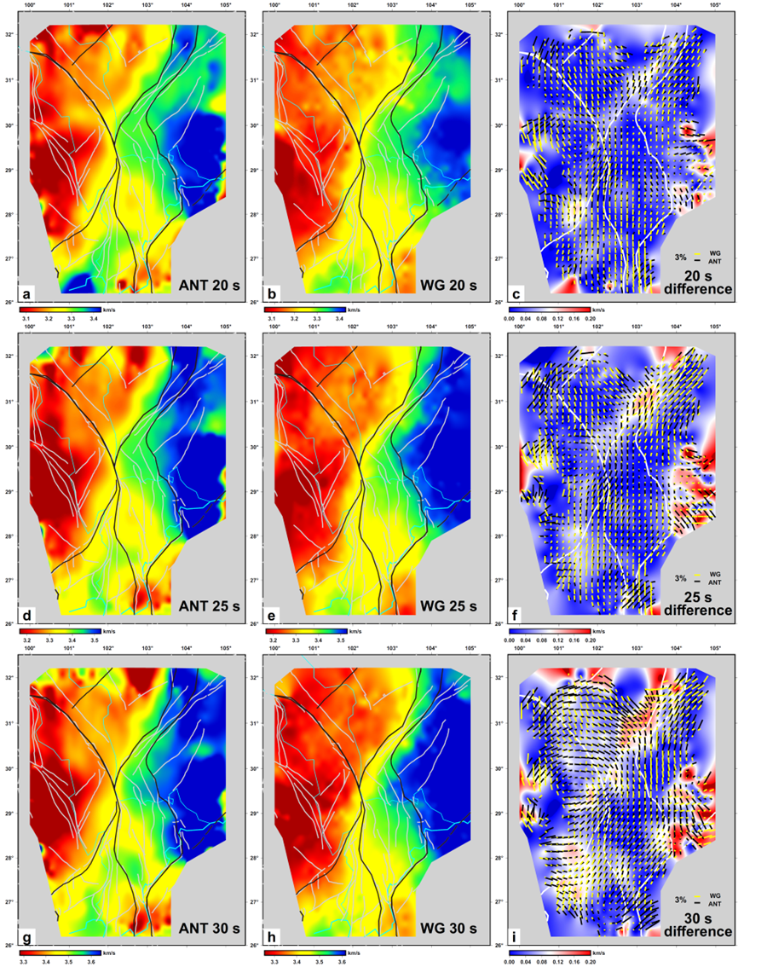

Figure S7. Maps showing the comparison between the results calculated using ambient noise tomography and wave gradiometry method. Figure (a), (d) and (g) show the phase velocity calculated using ambient noise tomography in periods of 20, 25 and 30 s respectively. Figure (b), (e) and (h) show the phase velocity calculated using wave gradiometry method in periods of 20, 25 and 30 s respectively. Base maps in figure (c), (f) and (i) show the absolute value of the difference between phase velocities calculated using ambient noise tomography and wave gradiometry. Black and yellow bars present the Rayleigh wave azimuthal anisotropy calculated using ambient noise tomography and wave gradiometry method, respectively.

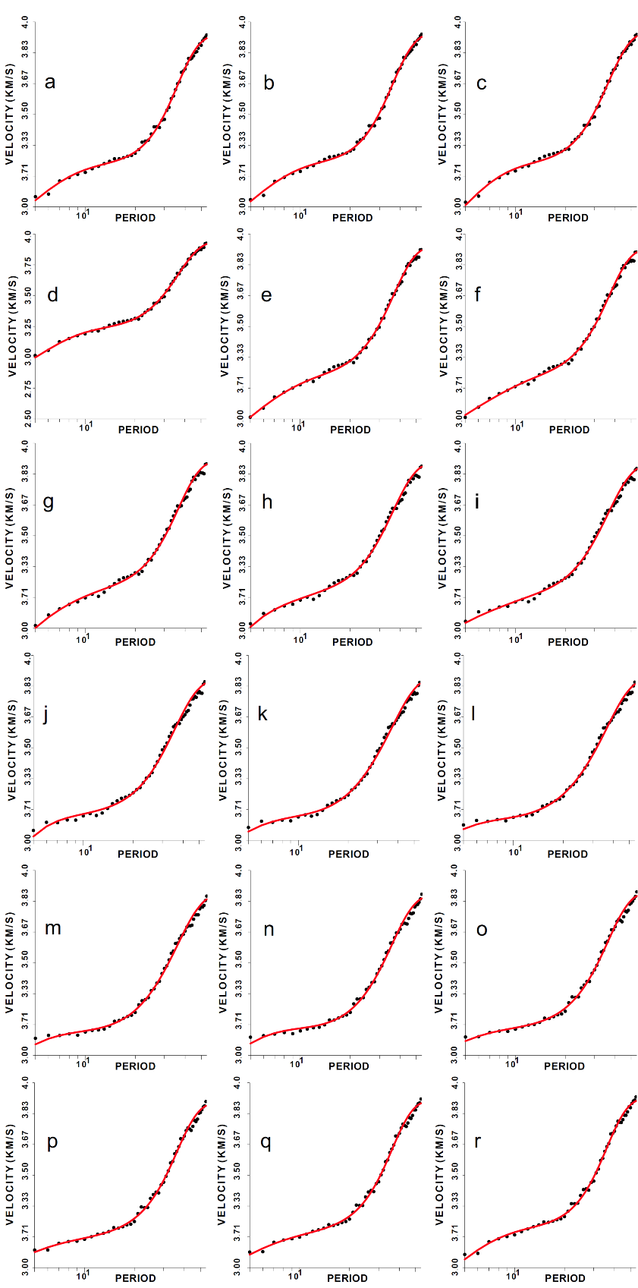

**Figure S8.** The azimuth-dependent dispersions of Rayleigh wave phase at grid point of 241 (E103.350 $°$, N28.150 $°$). Subfigure from (a) to (r) present the dispersions in back azimuth from 0 to 170. Black dots and red curves denote the observed and predicted results, respectively.

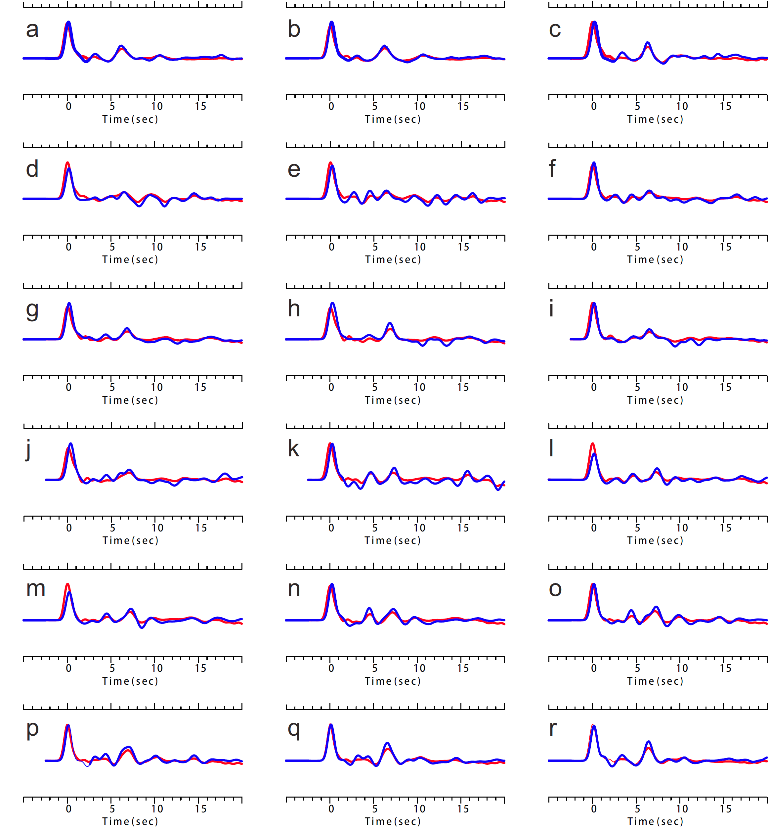

**Figure S9.** The azimuth-dependent receiver functions at station of XLB03. Subfigure from (a) to (r) present the receiver functions in back azimuth from 0 to 170. Blue and red curves denote the observed and predicted results, respectively.

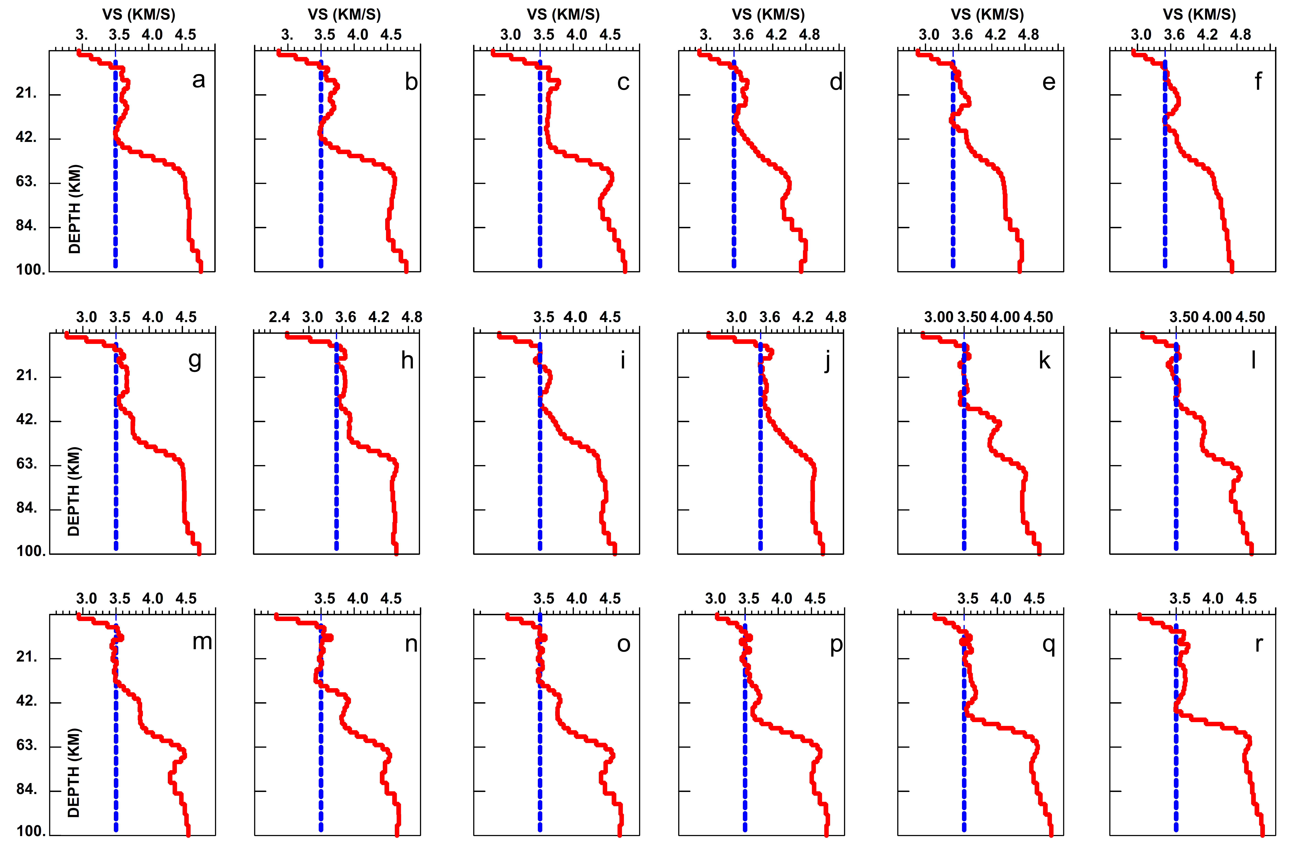

**Figure S10.** The Azimuth-dependent 1D Vs models inverted by the dispersion and receiver functions which showed in figures S3-S4. Subfigure from (a) to (r) present the Vs models in back azimuth from 0 to 170. Blue and red curves denote the initial and final model, respectively.



**Figure S11.** Examples of ADJI method for the azimuth-dependent 1D Vs models. RF is receiver function; Disp is dispersion curves.

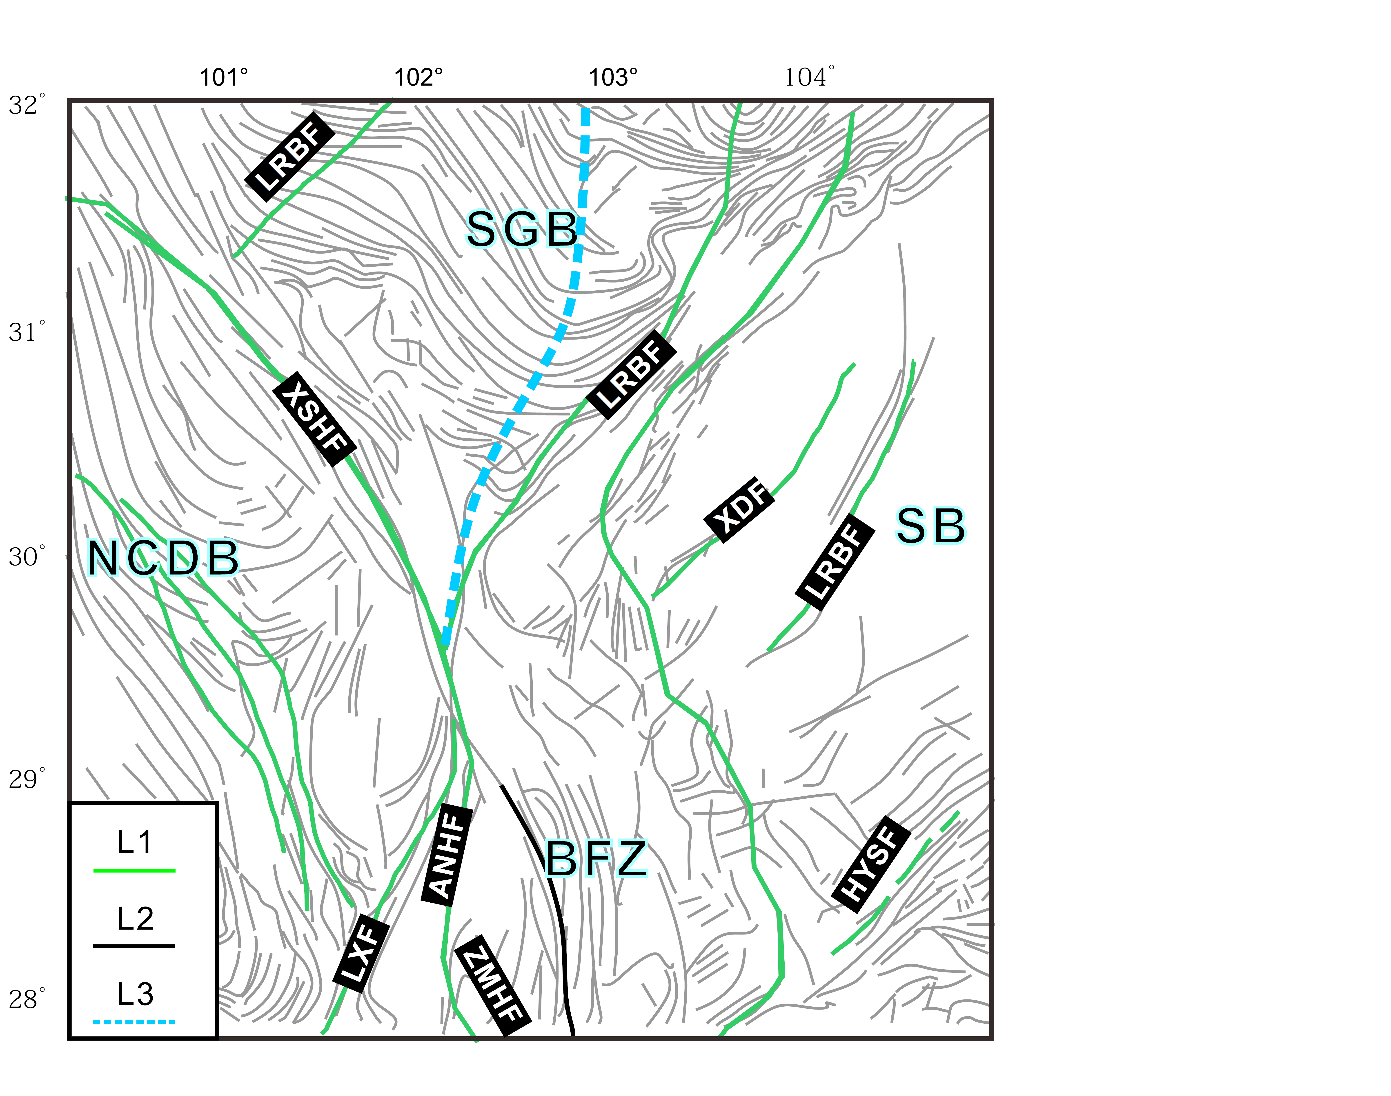

Figure S12. The major fault and block boundary (Deng et al. 2003) and the anticline/syncline axis (Burchfiel et al., 1995) in eastern Tibetan plateau. L1: block boundary and major faults; L2: anticline/syncline axis. L3: the northwest edge of Yangtze crystalline basement determined by Guo et al. (2015).

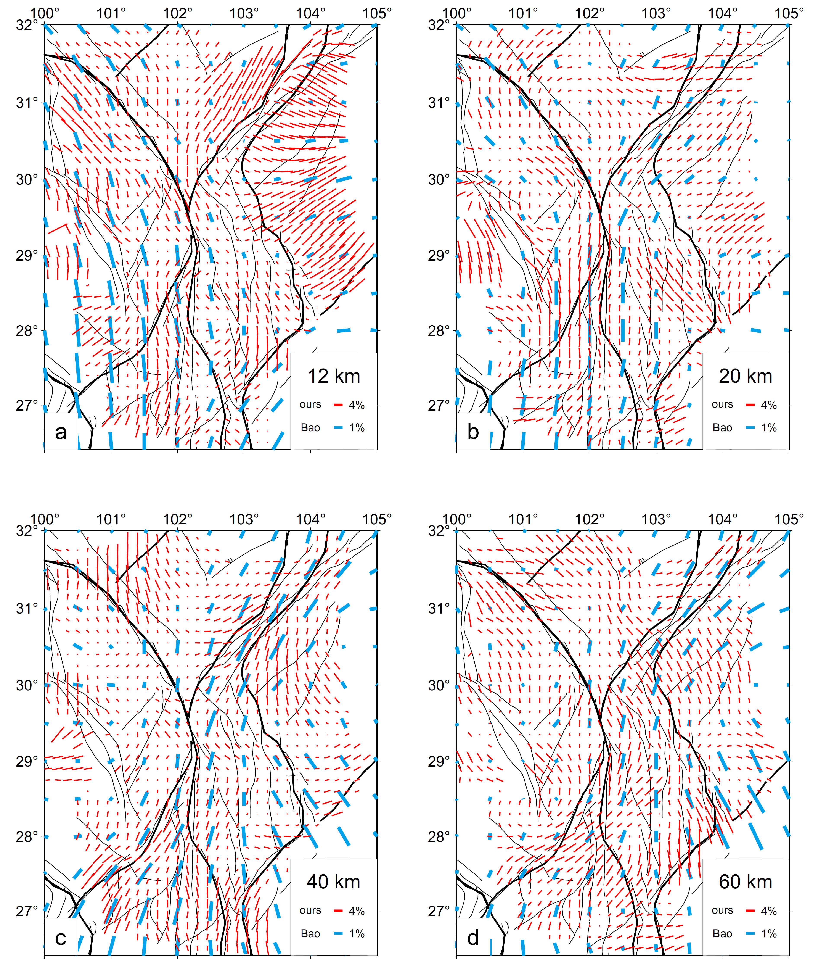Figure S13. Anisotropies in different depths. Blue bars: obtained by Bao et al. (2019); red bars: from this work.

Figure S14. The weighted average anisotropies in the depth range of 1~60 km based on results from Bao et al (2019) and this work. Red bards: based on this word; blue bars: based on Bao et al. (2019). Histograms show the different angles between the anisotropies computed from the two methods.